Barren County Schools are committed to providing you and your child with the highest quality preschool experience. However, if your child does not qualify for preschool services, we’d like to help you locate high quality childcare in a nurturing and learning environment.

Kentucky Child Care Assistance Program (CCAP)

If your child does not qualify for preschool services, you might be able to get assistance with the cost of childcare at a local daycare setting. See the information below and contact any licensed child care provider for more information.

The goal of the CCAP program is to provide access to quality child care that allows parents to work, attend education and training programs and/or participate in the Kentucky Temporary Assistance Program. Child care subsidies are also available for child protective services. Child care services through the CCAP are purchased from licensed, certified and registered providers.

To apply, go to https://prdweb.chfs.ky.gov/ccapapptrequest/RequestAppointment.aspx. Childcare providers can also help with the application process.

Child Care Assistance Program
Applicants who meet the criteria and income limits in the chart below may be eligible for this program to help working families with the cost of child care. Interested individuals may apply at their local Child Care Council of Kentucky office or online below. Please check the following websites for updates and more detailed information:
- CCAP offices are open 8:00 am – 4:30 pm daily (M-F) The contact number for Barren County is below:
- Allen, Barren, Green, Metcalf, Monroe [E] Alisha Wyatt 800-809-7076 (ph) 270-651-9224 (fx)
East Main Street Glasgow, KY 42142-1687 Monday-Friday (Other counties as needed) alisha.wyatt@ky.gov
To be eligible for the Child Care Assistance Program you must meet the following criteria;
- Resident of Kentucky; and the child must be a U.S. citizen or qualified alien; and
- Has employment an average twenty (20) hours per week for a single parent and forty (40) hours combined for a couple; or
- Have a child protective or preventive services authorization; or
- Is participating in the Kentucky Works Program; or
- A teen parent attending high school or pursuing a general equivalency degree (GED).
- Has a child under age of thirteen (13); or Nineteen (19) and is physically or mentally incapable of caring for himself.
- NEW: Homeless households are eligible for expedited services.
- At or below gross income in chart*.
CCAP INCOME LIMIT CHART (Effective September 1st, 2016)
Family Size | Annual Income Limit | Monthly Income Limit
2 | $25,632 | $2,136
3 | $32,256 | $2,688
4 | $38,880 | $3,240
5 | $45,504 | $3,792
6 | $52,128 | $4,344
7 | $58,768 | $4,897
8 | $65,424 | $5,452

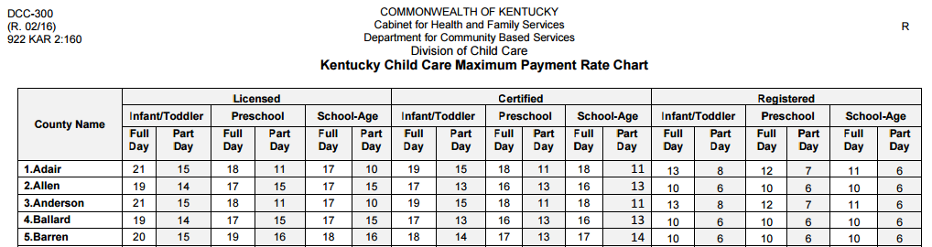

If you are searching for high quality childcare in Barren County, you might consider any of the STARS rated facilities listed below. Barren County Schools are partnering with the facilities listed to help expand and enhance early learning opportunities for our children. Either would be happy to talk to you about the CCAP program, as well as their early learning programs offered.
Let’s Go Play - Address: 218 Parkview Dr, Glasgow, KY 42141, Phone: (270) 651-8444
Barren County Head Start – Address: 899 Shamrock Pl, Glasgow, KY 42141, Phone: (270) 651-2419

Other STARS rated facilities in Barren County include:
Learning Tree Child Care, Inc., 600 South Dixie, Cave City, KY 42127
Learning Ladder Kids Academy, 1100 Cleveland Avenue, Glasgow, KY 42141
Children's Choice Academy, 1295 North Race Street, Glasgow, KY 42141

